GOVERNMET NAVEEN COLLEGE - GURUR
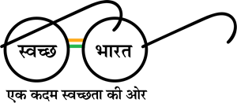
DISTRICT – BALOD (C.G.), INDIA
Contact No : 07749 – 265461 Email : gururgovernmentcollege@gmail.com Website : www.gcgurur.org.in

Feedback Analysis Session 2017-18
Numbers of Parent Participating to Fill-up Feedback Form

Class Name | No of Student in Class | No of Parents Participated in Feedback Process | % of Participation
B.Com III Year | 18 | 12 | 66.67 %
B.Sc. III Year | 41 | 35 | 85.37 %
B.A. III Year | 94 | 85 | 90.42 %
Total | 153 | 132 | 86.27 %

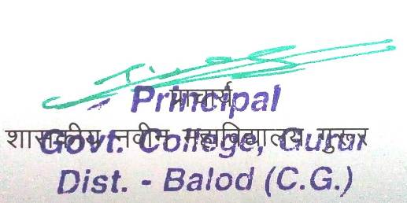
Question wise Feedback Analysis 2017-18
S.  No | Question | B.com III Year Parents |  |  |  |  | B.Sc. III Year Parents |  |  |  |  | B.A. III year Parents |  |  |  |  | Total Parents (III Year)
 |  | Excellence | Very Good | Good | Average | Poor | Excellence | Very Good | Good | Average | Poor | Excellence | Very Good | Good | Average | Poor | Excellence | Very Good | Good | Average | Poor
01 | Admission procedure | 04 | 05 | 02 | 00 | 01 | 06 | 14 | 11 | 02 | 00 | 02 | 30 | 47 | 03 | 03 | 12 | 49 | 60 | 05 | 04
02 | Infrastructure and lab facility | 03 | 02 | 06 | 01 | 00 | 03 | 06 | 20 | 04 | 01 | 03 | 12 | 67 | 03 | 00 | 09 | 20 | 93 | 08 | 01
03 | Work Culture observed by you and your Ward | 02 | 04 | 04 | 00 | 02 | 06 | 08 | 14 | 02 | 01 | 06 | 14 | 31 | 19 | 15 | 14 | 26 | 49 | 21 | 18
04 | Canteen facility | 00 | 00 | 01 | 02 | 08 | 00 | 00 | 03 | 07 | 23 | 00 | 02 | 11 | 09 | 63 | 00 | 02 | 15 | 18 | 94
05 | Library facility | 06 | 03 | 01 | 00 | 02 | 06 | 08 | 19 | 03 | 00 | 04 | 21 | 38 | 02 | 20 | 16 | 32 | 58 | 05 | 22
06 | Other facilities provided by the college | 03 | 03 | 01 | 03 | 02 | 05 | 10 | 13 | 05 | 02 | 08 | 06 | 52 | 07 | 11 | 16 | 21 | 66 | 15 | 15
07 | Sports and cultural activities | 04 | 04 | 04 | 00 | 00 | 07 | 12 | 13 | 02 | 00 | 06 | 28 | 55 | 03 | 02 | 17 | 44 | 72 | 05 | 02
08 | Student's counseling activities | 04 | 04 | 04 | 00 | 00 | 03 | 14 | 12 | 05 | 01 | 16 | 20 | 40 | 07 | 02 | 23 | 38 | 56 | 12 | 03
09 | Student's counseling and guidance | 04 | 03 | 04 | 00 | 00 | 06 | 12 | 12 | 03 | 01 | 06 | 17 | 52 | 05 | 03 | 16 | 32 | 68 | 08 | 04
10 | Use of Information and communication technology in the college | 00 | 00 | 02 | 00 | 09 | 00 | 06 | 10 | 08 | 07 | 06 | 11 | 42 | 02 | 22 | 06 | 17 | 54 | 10 | 38
11 | Academic Discipline (in lectures, practicals and related activities) observed by the college | 01 | 07 | 03 | 00 | 00 | 05 | 13 | 14 | 02 | 01 | 22 | 31 | 29 | 03 | 00 | 28 | 51 | 46 | 05 | 01
12 | Improvement in soft skills, knowledge, ethics, morality, observed by you in your ward | 04 | 04 | 02 | 00 | 01 | 05 | 15 | 10 | 03 | 00 | 03 | 47 | 25 | 09 | 00 | 12 | 56 | 37 | 12 | 01
13 | Evaluation and Feedback mechanism | 04 | 00 | 07 | 00 | 00 | 00 | 11 | 16 | 07 | 00 | 04 | 14 | 58 | 07 | 00 | 08 | 25 | 81 | 14 | 00

Chart 01 for B.Com III year Parents

Chart 02 for B.Sc III year Parents

Chart 03 for B.A. III year Parents

Chart 04 for Total (B.Com, B.Sc. & B.A.) III year Parents

